# Daylight intensity of images:

We considered the average values of part of the reference board (highlighted in below image; rows 780:785, and columns 10:310) as daylight intensity for that particular image.

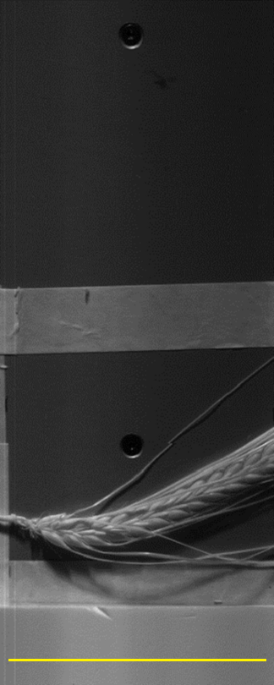

As far as we took this value as daylight intensity level, we noticed that this value is not stable along all channels of that particular image.

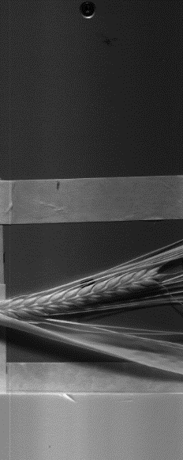

256

0

In addition you can take a look on below image.

The spectrum values of grains drastically decrease while the reference board is somewhat stable.

Therefore, we took the intensity level for each channel of each images.

Below chart is intensity level along all channels of three images.

After preparing this data, we took the **minimum intensity value of each channel** (referring image number) as reference and added the difference of the intensity level on top of respective channel of each image.

Below chart is the result of adding intensity level difference on three images.

# Results of algorithms

## Lasso:

For **Maltose we get around R^2 = 0.15** while for all the rest of **target variable we get around zero**.

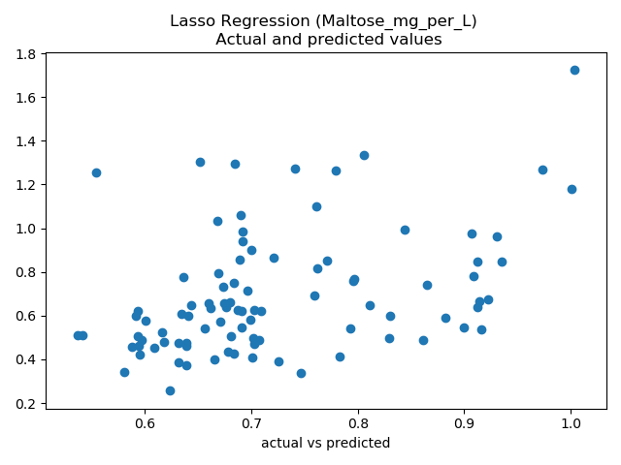 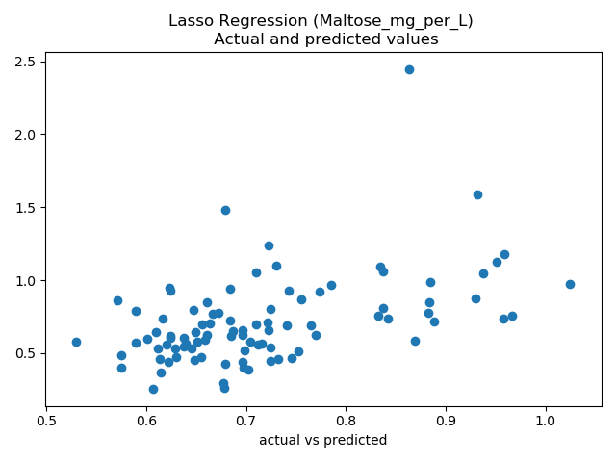

Figure 1: R^2 = 0.152 Figure 2: R^2 = 0.216

## Elastic Net

For **Maltose we get around R^2 = 0.18** while for all the rest of **target variable we get around zero**.

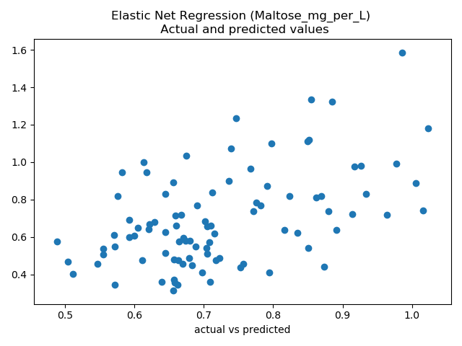 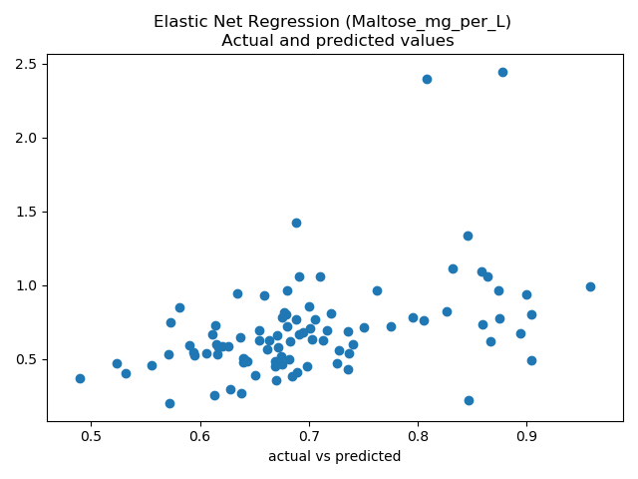

Figure 3: R^2 = 0.244 Figure 4: R^2 = 0.177

## Ridge

Ridge works very poorly in all even for Maltose **results R^2 around zero**.

## SVR

For SVR results please take a look on **SVR_2cp.pdf file** included in attachment of email.

|  |  |  |  |
| --- | --- | --- | --- |
| Tasks | Expected Date | Done | Assigned to |
| Literature Research | 12.Dec.2019 | Yes | All team members |
| Segmentation | 01.Mar.2020 | Yes | Saied |
| Management of Data (downloading images and resizing VNIR images) | 05.Mar.2020 | Yes | Ramkishore |
| Merging images | 10.Mar.2020 | Yes | Saied |
| Preparing Dataset | 15.Mar.2020 | Yes | Saied |
| Ridge, Lasso, Elastic Net | 5.Apr.2020 | Yes | Saied |
| SVR | 07.Apr.2020 | Yes | Raman |
| OLSLR | 07.Apr.2020 | Yes | Ramkishore |
| PLSR | 07.Apr.2020 |  | Amit |
| RFR | 07.Apr.2020 |  | Devish, Sudheer |
| Comparing Algorithms | … |  | Saied, Amit, Raman |
| Documentation | … |  | Amit, Raman, Ramkishore, Sudheer, Devish |